

Affiliated to the
Incorporated Association
Of Organists
April 2024
Last issue Feb 2024
Diary Dates 2024
Mainly an outline of events we hope to hold this coming year.
Dates subject to confirmation.

27th April, 5pm BDOCA Singers Evensong
11th May, 2pm Hand Bells at The Vine, Welling
14th June, 7:30pm Celebrity Recital – Herman Jordaan – St John’s,
Sidcup
31st July, 12:00 Summer lunch at White Cross Inn, North Cray
17th August, 2pm Treasure Hunt
25th Sept, 7:30pm Composite Recital & BDOCA AGM – All Saints’, Foots Cray

Further details about events in this and future issues

Please do support these events - the more the merrier!

Inside this issue:

Diary Dates 1
BDOCA Singers Evensong 1
BDOCA Singers
Membership 1
Hand Bells 2
Website 2
Bursary 2
Quiz Answers 2
Organ Crawl Report 3
Wordsearch 4
Danial Moult Recital 5
Your committee 5

BDOCA Singers Evensong
Saturday 27th April, 5pm.
St Paulinus church, Manor Road, Crayford

Introit: Now the green blade riseth. Old French harm. Arr.Martin Shaw/ RGB
Ebdon: Preces & Responses
Ps. 84: Quam dilecta! C H H Parry
Holman Magnificat & Nunc dimittis in F min
H Walford Davies: O sons and daughters
Hymn: Farley castle. Most glorious Lord of life

BDOCA Singers Membership

The BDOCA Singers are keen to increase membership. The SATB choir was formed in 2018 and first sang Evensong in March 2019. The proposal at that time was to sing Choral Evensong 2-3 times a year at various churches in the area with 4-5 rehearsals in the preceding months. The pandemic interrupted this somewhat, but the choir resumed in 2022 and the Evensong at St Mary’s, Welling, in October was the second such service given in 2023 (report later in this issue). In order to continue to enjoy a varied and interesting repertoire, the choir needs to grow. Rehearsals are held at All Saints’ church, Foots Cray. Singers do not have to be BDOCA members and there is no subscription fee other than a small donation for the church at each rehearsal, so please spread the word.

Hand Bells at The Vine,
Axminster Crescent, Welling, DA16 1HF
Saturday, 11th May, 2pm

Give us a ring!
Come and enjoy an afternoon of Hand Bell ringing on Saturday the 11th May at 2.00 pm – it was great fun last time we did it. A variety of music and tunes to play and hear.
This is being held for you at The Vine Christian Community Church, Axminster Crescent DA16 1HF. There is a free car park next to the church in front of the adjacent hall.
And, of course, refreshments will be provided.
Page 2

Website

In conjunction with Alan Hunt (who has kindly run our website for many years), Aeron has updated it. Aeron now invites contributions and also needs to update the “available to deputise” information.

Your contributions will be very welcome.

Bursary

BDOCA is keen to encourage youngsters to learn the organ and will give sympathetic consideration to requests for financial support. Please write to Melvyn with your request and supply supporting details.

Answers to quiz questions set in the February Newsletter:

10. Sarah MacDonald.
11. Sweden.
12. Rossini.
13. Sheffield.
14. 85 dB(A).
15. A large plucked string instrument of the lute family.
16. Lizet.
17. On a guitar or similar instrument.
18. 6.
19. 1812.
20. Arudel.

1. Kettle Drums.
2. Make a Joyful sound.
3. Salisbury.
4. 1830 - 1900.
5. approx 5000.
6. Norwich.
7. Handheld piano-style keyboard which is blown through to make a sound.
8. Ravels Bolero.
9. A piece of orchestral music, usually in a single continuous movement, which illustrates or evokes the content of a poem.

Organ Crawl Report

On the 24th February, 10 of us gathered at St. George’s Beckenham for a look at, and play on, the organ. A lovely 4 manual with a mellow sound unless you add the tuba! It was originally built by Forster and Andrews in 1887 and has undergone several upgrades. In 1984 Kenneth James rebuilt and extended the instrument and added the 4th manual. We all had a play of various styles of music to check its versatility and took the opportunity to eat our pack lunches.

When we were all gathered, we headed off on the 54 bus toward Catford and then walked up to St. Dunstan’s church, Bellingham.

The organ was originally built for the Chapel Royal, St. James’ Palace by Hill and Son in 1868. The case then was a second hand one built in 1837 by Hill and Davidson. St Dunstan’s was originally designed as a much larger church to hold 300+ people but work stopped during the General Strike of 1926 and the church was completed by the apprentices so stopped rather abruptly and with a fairly plain, flat East End at half the original size. The organ is at the West End and was overhauled in 2017. It has a nice sound but needs getting used to as the pedals are slightly offset and the stops crowded to make it difficult to spot them quickly.

It also has lever pre-selects, so no easy piston changes. The sound is good and the church, although unused at the moment because the boiler is broken and no heating (still warmer than my church!), has good acoustics due maybe to high ceiling.

After this we headed to the bus stop to get the bus toward Catford and walked up the hill to Hither Green and St Swithun the Evangelist. The Conacher organ there is a fine 2 manual instrument, although it started life as a 3 manual organ in Blenheim palace. When Father Willis replaced the Blenheim palace organ with a larger 4 manual instrument, he installed the old one in St. Swithun's placing the pipework in the North-East chancel. In 1959 Sidney George Tuddenham (then organist) paid for reworking and rebuilding of the organ making it a 2 manual with some fine solo stops. It had a good sound with some interesting solo stops. The acoustics in this church were also good. At this point we assembled for a group photo to prove we really did it.

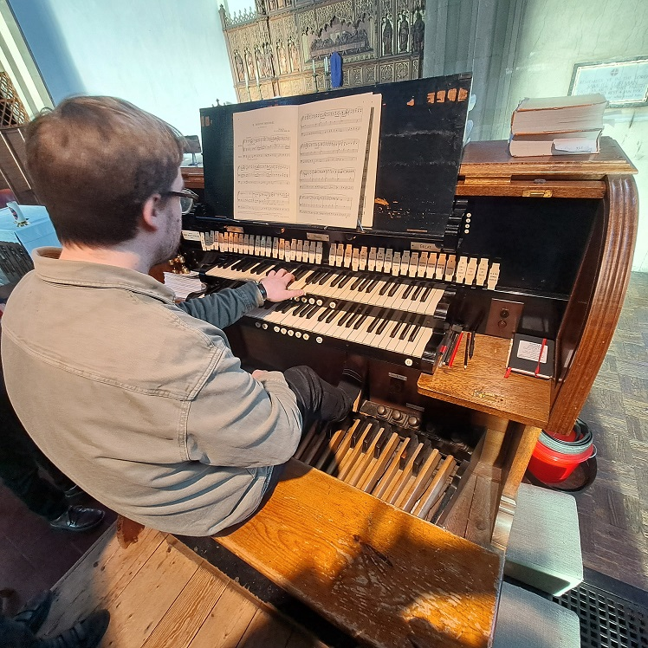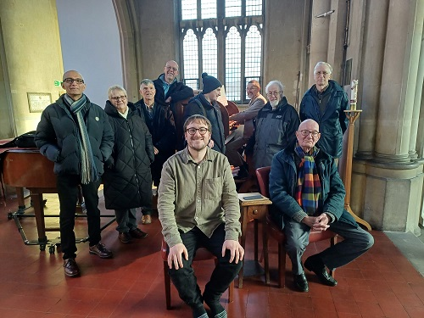
Cont……..
Page 3
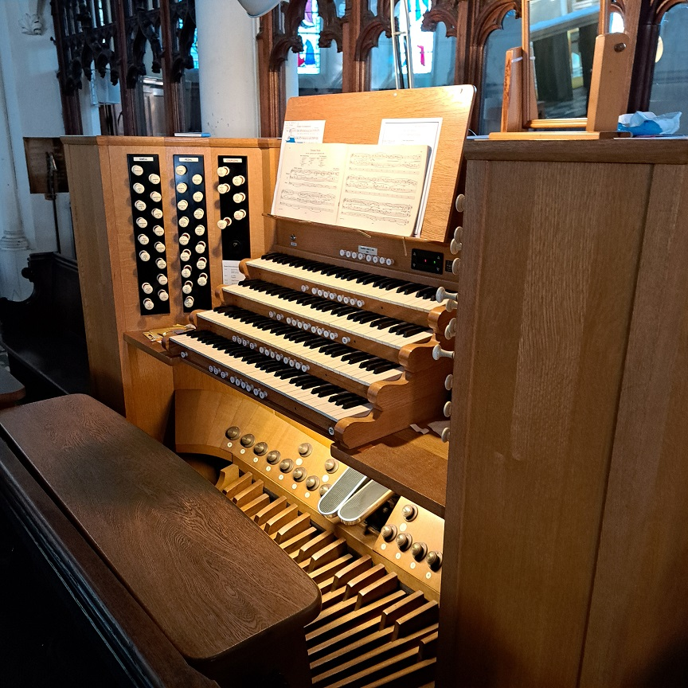

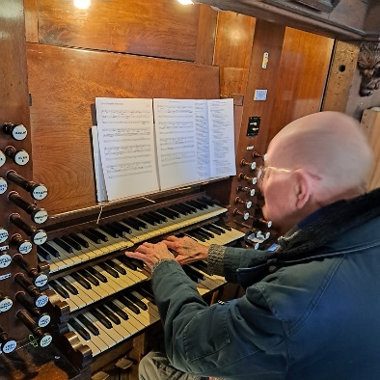

……cont.

After St Swithun’s we walked into Lewisham and some got the bus, some walked to St. Margaret’s, Lee (which I would call Blackheath!) where we were greeted by the current director of music Duncan Atkinson. WOW! What a stunning church, all painted floor to ceiling, fine rood screen and a fine organ which started off life as a Bishop and Son opened in 1850 by no less than Samuel Sebastian Wesley. It was rebuilt and enlarged in the 1875 by Walkers when work was also carried out on the church fabric.

Walkers then further enhanced it to its current state in 1928. After a demonstration by way of Duncan playing some Frank Bridge to highlight the range of the organ a couple of us had a quick go, it was then getting dark and we were hungry, so we bade farewell and headed off to a very nice meal at Côte brasserie in Blackheath. A fine day was had by all and we all got our steps in as well as flexing our bus passes :)

Nik Kerwin.

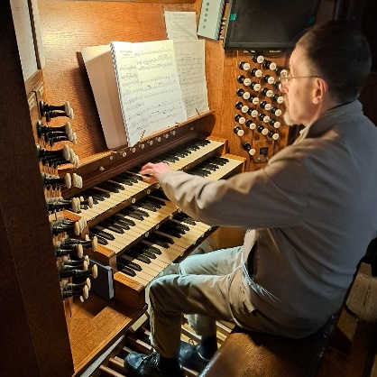
Page 4

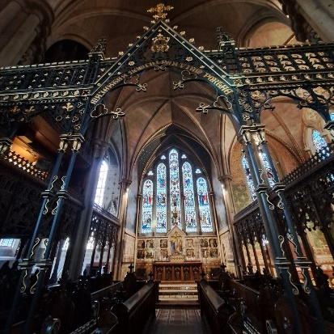

Musical Terms Word Search

G | R | A | V | E | L | Q | X | L | O
C | W | N | S | I | E | A | D | O | C
R | J | D | E | G | N | F | U | I | O
E | A | A | M | O | T | S | E | R | P
S | I | N | P | R | O | Y | K | B | W
C | C | T | L | O | I | G | A | D | A
E | R | E | I | S | E | T | R | O | F
N | A | R | C | O | T | A | B | U | R
D | M | J | E | C | L | O | D | T | Z
O | E | L | I | B | A | T | N | A | C

ADAGIO CANTABILE CRESCENDO DOLCE FORTE

BRIO LENTO GRAVE MARCIA SEMPLICE POCO

RUBATO VIGOROSO PRESTO ANDANTE CODA

Daniel Moult’s concert at the Temple

On Wednesday 27th March, myself and Mrs K ventured into London. We have a book, “Literary walks of London”, so we strolled around Holborn and Lincolns Inn looking at Dickens’ old work place in a solicitors in Grays Inn and the John Soanes Museum among other things. Very handily, as it started to rain, we went to the Temple Church to see our patron Daniel Moult give a short recital. We placed ourselves opposite the organ with a good view of the console. Daniel introduced the concert and explained that the music was chosen to reflect the passion moving through different emotions, anger/acceptance/Good Friday anger and pain and finally Easter Sunday triumph. Interesting.

So, we commenced with Bach’s Fantasia in G minor (BWV 542i), reported to have been written as a response to the death of his son (one of). I love this fantasia with its Toccata like flowing movements and underlying minor chords through the quiet canonic interludes and that final pedal motif to the C Major(?) chord. My edition has C minor before moving to the fugue (which was not played today). Which is best? Fight amongst yourselves, but I like the minor finish. It was very noticeable how the pedal, loud or soft, vibrated right through you.

We then moved to a Study in canonic form by Schumann, played softly on flutes, was an oasis of peace before we moved on to the mighty Sonata in F minor by Mendelssohn. This put the organ through its paces with a forceful Allegro moderato e series, a quiet contemplative Adagio, then, POW! fff, full organ which made the lady next to me jump with fright (ha ha ha), with extreme contrast a pp, followed by a grand Allegro assai vivace. Excellently interpreted and performed.
We then moved to a Petit Canon by Boulanger. I confess I did not know this, but loved it. It is taken from Nadia Boulanger’s Trois Improvisations from around 1912. Well worth looking up if you have never heard it.

Finally, we finished with Widor symphony no. 5. No, not the toccata, the Allegro vivace. A great triumphal finish on what I thought was full organ, until the last phrase - a great sound.

There were around 100 people in attendance including our own Geoff Hempstead, and we gave Daniel rapturous applause for a fantastic musical experience and tour of the Temple organ.

I had a quick word with Dan afterward who was grateful for support and also glad to be back on the tech after a 3 month break due to back surgery. But he is now fighting fit with renewed vigour. I look forward to his next concert.

Nik Kerwin
Page 5

Your Committee
Reg. Boulton, President  020 8658 7455 or 07889 172319  reg.boulton@btopenworld.com  Aeron Preston, Vice-president  07775 063987  aeron.glyn.preston@gmail.com  Doug Snow, Treasurer  020 8304 5229  dougsnow.organist@yahoo.co.uk | Melvyn French, Secretary  melvynfrench7@gmail.com  Lydia Gray, Asst. Secretary  01322 551286 or 07426 807758  lg35@lydiagray.plus.com  Barrie Bishop, Ordinary Member  barriebishop2@gmail.com | Bruce Davis, Ordinary Member  01322 558129  bruce.davis11@yahoo.co.uk  Marilyn Downs, Ordinary Member  01322 294569 or 07979 611472  marilyn.downs1950@gmail.com  Peter Mitchell, Ordinary Member  07770 931477  petermit@aol.com

